UNIT III
- Draw the symbols of OR, AND, NOT, NOR, NAND, XOR and XNOR gates. Write their logic expressions and truth tables
- What are universal logic gates? Why they called so? Explain truth table and the functionality of universal gates?
"Universal logic gates" are the NAND and NOR gates.
Both NAND and NOR gates can perform all basic logic functions AND, OR, NOT when combined appropriately.
NAND Gate
A NAND gate is a combination of an AND gate followed by a NOT gate. It outputs a 0 only when all its inputs are 1; otherwise, it outputs 1.
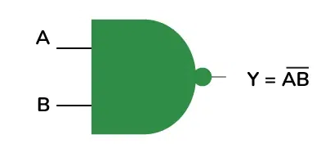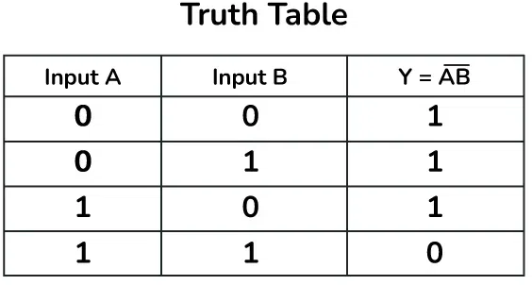
NOR Gate
A NOR gate is a combination of an OR gate followed by a NOT gate. It outputs a 1 only when all its inputs are 0; otherwise, it outputs 0.
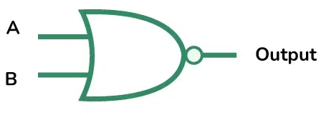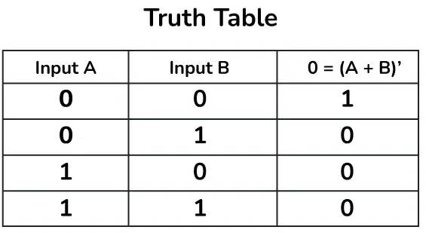

- What is Excess-3 code, Grey code and Hamming code?
Excess-3 code:
A non-weighted binary coded decimal (BCD) code where each decimal digit is represented by adding 3 to its corresponding BCD value, essentially "shifting" the binary representation by 3; used for its self-complementing property where the 1's complement of an Excess-3 code represents its 9's complement.
Gray code:
A non-weighted binary code where only one bit changes between any two consecutive numbers, making it useful for applications where smooth transitions between states are important, like analog-to-digital conversion; also known as reflected binary code.
Hamming code:
An error detection and correction code that adds parity bits to data to identify and fix single-bit errors during transmission; designed to detect and correct errors in data by strategically placing extra bits based on a mathematical formula.
- Write the equivalent Binary code, BCD code, Excess-3- code and Grey code for the decimal numbers from 0-15.
Decimal | Binary Code | BCD | Excess-3 Code | Grey Code
0 | 0000 | 0000 | 0011 | 0000
1 | 0001 | 0001 | 0100 | 0001
2 | 0010 | 0010 | 0101 | 0011
3 | 0011 | 0011 | 0110 | 0010
4 | 0100 | 0100 | 0111 | 0110
5 | 0101 | 0101 | 1000 | 0111
6 | 0110 | 0110 | 1001 | 0101
7 | 0111 | 0111 | 1010 | 0100
8 | 1000 | 1000 | 1011 | 1100
9 | 1001 | 1001 | 1100 | 1101
10 | 1010 | 1010 |  | 1111
11 | 1011 | 1011 |  | 1110
12 | 1100 | 1100 |  | 1010
13 | 1101 | 1101 |  | 1011
14 | 1110 | 1110 |  | 1001
15 | 1111 | 1111 |  | 1000
- What is a combinational circuit and sequential circuit.
Combinational Circuit: A combinational circuit is a type of digital circuit where the output is determined solely by the current inputs. In other words, the output at any given time is a direct function of the inputs at that same time, without any memory or feedback elements involved. Examples include adders, multiplexers, and encoders.
Sequential Circuit: A sequential circuit, on the other hand, has outputs that depend not only on the current inputs but also on past inputs. This means that sequential circuits have memory elements that store information about previous states. The output can change based on the history of inputs, making these circuits suitable for applications like registers, counters, and finite state machines.
- Draw the circuit diagram of Half adder and explain the operation with truth table.
The Half Adder: A Half Adder is a combinational circuit with two binary inputs and two binary outputs (sum and carry bits.) It adds the two inputs (A and B) and produces the sum (S) and the carry (C) bits. It is an arithmetic operation of addition of two single bit words.
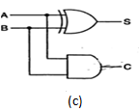
Fig (a) Truth Table (b) Block Diagram (c) Logic Diagram
The Sum(S) bit and the carry (C) bit, according to the rules of binary addition, the sum (S) is the X-OR of A and B. Therefore, S = AB’ +BA’
The carry (C) is the AND of A and B.Therefore, C=AB
A half-adder can be realized by using one X-OR gate and one AND gate.
- Draw the circuit diagram of full adder with two half adders and explain its operation with truth table.
The Full Adder:
A Full-adder is a combinational circuit that adds two bits and a carry and outputs a sum bit and a carry bit.
To add two binary numbers, each having two or more bits, the LSBs can be added by using a half-adder.
The carry resulted from the addition of the LSBs is carried over to the next significant column and added to the two bits in that column.
So, in the second and higher columns, the two data bits of that column and the carry bit generated from the addition in the previous column need to be added.
The full-adder adds the bits A and B and the carry from the previous column called the carry-in Cin and outputs the sum bit S and the carry bit called the carry-out Cout .
The variable S gives the value of the least significant bit of the sum. The variable Cout gives the output carry.

The eight rows under the input variables designate all possible combinations of 1s and 0s that these variables may have.
The 1s and 0s for the output variables are determined from the arithmetic sum of the input bits. When all the bits are 0s , the output is 0.
The S output is equal to 1 when only 1 input is equal to 1 or when all the inputs are equal to 1.
The Cout has a carry of 1 if two or three inputs are equal to 1.
- Define Flip Flops, registers and Counters. Explain SR Flip Flop
Flip Flops
Flip-flops are fundamental building blocks of sequential circuits used for storing binary data. They are bistable devices, meaning they have two stable states, and can hold one bit of information (either 0 or 1). Flip-flops are crucial for memory storage, data transfer, and state management in digital systems.
Registers and counters
Registers and counters are essential components in digital electronics that utilize flip-flops to store and manipulate data. Each serves distinct purposes and plays a vital role in data processing, control systems, and various digital applications.
Registers
Definition: A register is a small amount of storage available directly in the CPU or other digital devices that can hold multiple bits of data. Registers are used to store temporary data and are fundamental for operations such as arithmetic calculations and data transfer.
Counters
Definition: A counter is a sequential circuit that counts pulses or events and typically outputs a binary number representing the count. Counters can be either synchronous or asynchronous.
SR Flip-Flop (Set-Reset):
Inputs: Set (S) and Reset (R).
Function: When S is high, the output (Q) is set to 1; when R is high, Q is reset to 0. If both S and R are low, the output remains in its previous state. If both are high, it leads to an undefined state.
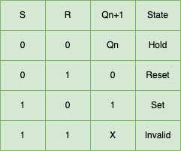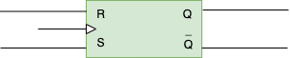

- Truth Table (b) Symbol
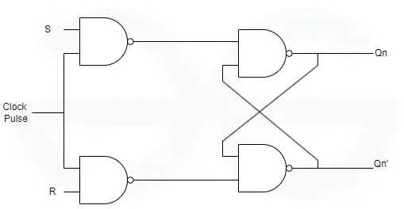
( c ) Logic diagram using only NAND gates
Working of SR Flip Flop
Case 1 : Let’s say, S=0 and R=0 , then output of both AND gates will be 0 and the value of Q and Q’ will be same as their previous value, i.e, Hold state.
Case 2 : Let’s say, S=0 and R=1 , then output of both AND gates will be 1 and 0, correspondingly the value of Q will be 0 as one of input is 1 and it is a NOR gate so it will ultimately gives 0, hence Q gets 0 value, similarly Q’ will be 1.
Case 3 : Let’s say, S=1 and R=0 , then output of both AND gates will be 0 and 1, correspondingly the value of Q’ will be 0 as one of input to NOR gate is 1, so output will be 0 ultimately and this 0 value will go as input to upper NOR gate, and hence Q will become 1.
Case 4 : Let’s say, S=1 and R=1 , then output of both AND gates will be 1 and 1 which is invalid, as the outputs should be complement of each other.

